**FOR IMMEDIATE RELEASE** Media Contact: Amber Gifford

February 18, 2021 [agifford@popud.org](mailto:agifford@popud.org) / 509-447-9328

**Riverview Water Treatment Facility Now Active**

Improved water quality for PUD customers at Riverview

Newport, WA – Public Utility District No. 1 of Pend Oreille County (PUD) is pleased to announce that a new water treatment facility at its Riverview Water System is now active. The PUD’s Riverview Water System serves approximately 59 customers and has been in need of a water filtration system to remove arsenic and manganese from the water. Approximately a year ago, the PUD had a design completed and went out to bid for construction of the facility. In September of last year, the project was awarded to TML Construction, they broke ground in early November, and worked over that last three months to complete the project.

The facility was officially activated on February 10, 2021, and all that remains to be done is beatification of the site this spring. The new filter and water system is currently serving the customers at Riverview and residents are enjoying high-quality drinking water. The project included installation of an arsenic, iron, and manganese removal treatment system rated at approximately 50 gallons per minute. The project also involved additional upgrades such as installation of treatment units, a backwash system, new water reservoirs, and pump house upgrades. In addition, the new 9,200-gallon water reservoir that was installed will provide system capacity to Riverview Water customers during peak usage.

The PUD procured funding for this project through a fully subsidized loan totaling nearly $250,000 from the Department of Health’s Drinking Water State Revolving Fund, as well as a low-interest loan for a similar amount to cover the cost of this nearly $500,000 project.

“Our Riverview Customers have long been anticipating the completion of this exciting project. This new filtration system and upgrades will ensure quality drinking water for many years to come,” said Mark “Bubba” Scott, the PUD’s Water System Manager. “We are continuously looking for ways to provide value to our customers and deliver a quality product.”

The PUD owns and operates nine community water subdivisions: Metaline Falls, Lazy Acres, Sunvale, Holiday Shores, Riverbend, Riverview, Sandy Shores, Green Ridge and Granite-Sacheen Water System. The water division is staffed by the PUD’s Water Systems Manager and two Water System Operators. All nine water systems combined provide drinking water to approximately 600 customers in Pend Oreille County, delivering approximately 46 million gallons of water in 2020.

**About Pend Oreille County Public Utility District**

Pend Oreille PUD was established in 1936 and began operations in 1948. The PUD is governed by three locally elected Commissioners. A General Manager and staff operate the utility within policies set by the Board of Commissioners. The PUD has four operating systems: The electric system distributes electricity to the county, the production system produces power from the Box Canyon Hydroelectric Project, the water system consists of nine individual water distribution subdivisions, and the community network system provides wholesale broadband communication services. For more information visit: [http://popud.org](http://popud.org/).

# # #

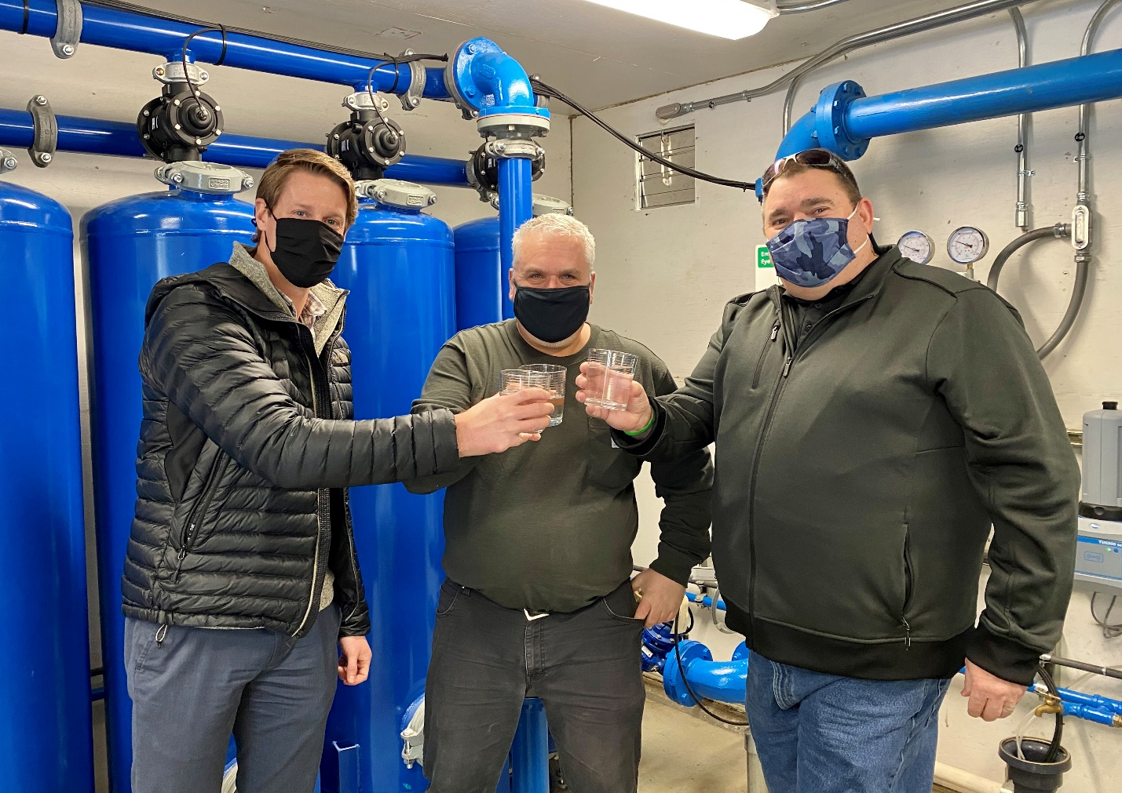

*Colin, Rusty & Bubba at the new Riverview Water Facility getting ready for their first taste of quality water straight from the tap on February 17, 2021.*

Pictured from left to right:

Colin Willenbrock, PUD’s General Manager

Rusty Gill, PUD’s Lead Water System Operator

Mark “Bubba” Scott, PUD’s Water System Manager